THEMATICALLY ORGANIZED ASSESSMENT
GERMAN

TOA Title: La croisade verte pour sauver la ville

Theme: Environment

Level: Pre-Advanced

TOA Overview:

This is the end of the school year; your achievement at school is excellent and you are waiting to know who has been selected to go to China! Yes, China needs advice from students involved in the community and environment to get ready for the Olympics. You enjoy sports and environment and are very excited to know if you were selected. The results are here! You are leaving! Peking is a big town. Your friend went to spend his/her vacation in another major town (of his/her choice). You will listen to and read information about environmental issues. You will then discuss the pollution problems, possible solutions to the problems, prevention, actions already taken, problems solved… Finally, you will then create a report for the Olympic Committee to help them choose the city that will host the 2012 Olympic Games.

TOA Title: La croisade verte pour sauver la vil

Task Title: Story: Une croisade verte pour sauver la ville

Theme: Environment

Level: Pre-Advanced Focus Age Group: 15 – 18 years

National Standards Goals: Communication Cultures Connections Comparisons Communities

Communicative Mode: Interpretive

Time Frame: Two 45 minute class periods

Description of Task:
This is the end of the school year; your achievement at school is excellent and you are waiting to know who has been selected to go to China! Yes, China needs advice from students involved in the community and environment to get ready for the Olympics. You enjoy sports and environment and are very excited to know if you were selected. The results are here! You are leaving! The Olympic committee is sending you a tape with the major issues you will need to address with a professional. You will listen to the tape, take notes to answer questions your friends and family will ask you and then read a text. The whole school is excited that you have been chosen as a representative! You will of course answer the questions in French in your own words.

Materials Needed: Recorded text, see icon on next page, the accompanying text, paper and pencils.

Teacher Notes: Students have knowledge about the problems of pollution in the world, know about recycling and solutions to prevent pollution….The teacher will have to introduce new words found in the text during the week/s prior to the assessment. During classes prior to the assessment, the teacher should discuss the different types of pollution including air, water, earth, and automobile pollution.

UNE CROISADE VERTE.

Here is the listening comprehension.

If you want to read it to the students, it is the first part of the text below.

Click on the icon below to hear the listening comprehension.



Here are the questions concerning the listening comprehension:

- Qu’est-ce qui fait le bonheur des gastronomes de la capitale?

- Qu’est-ce qui repand trop de fumée?

- De quoi est –il important que Pékin se préoccupe?

- A quel rang des pollueurs mondiaux est-ce que Pékin se trouve?

- A combien s’élève le budget que Pékin a débloqué?

- Qu’est-ce qui accable Pékin?

Attached here is the text to give to students. Don’t forget to take off the first part that is the listening comprehension. Take off the 2 first paragraphs, up to “un embryon de débat public sur le sujet.”

La première version du texte comprend l’écoute et la comprehension.

La deuxième partie du texte ne correspond qu’à la lecture et compréhension.

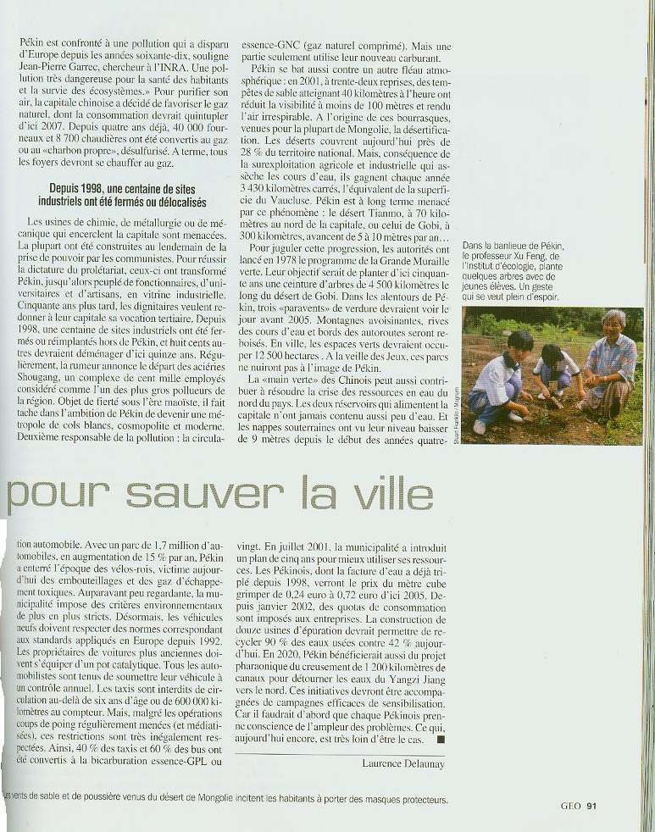
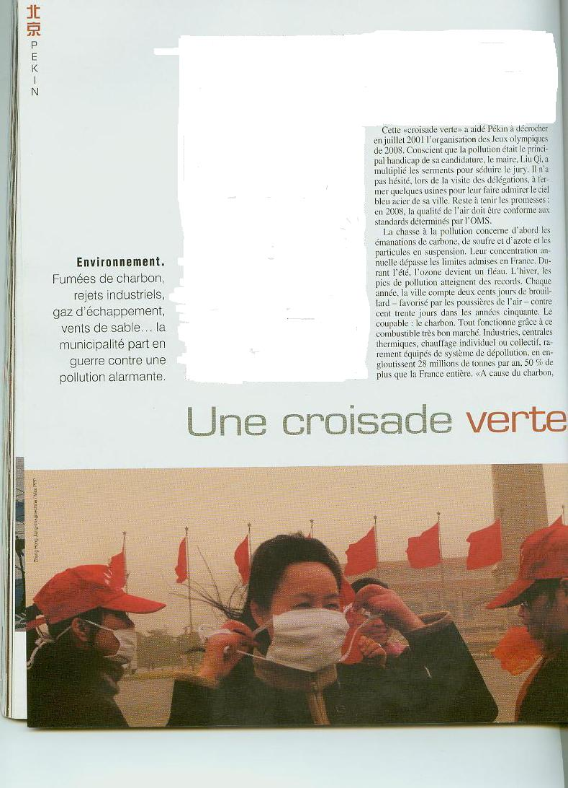
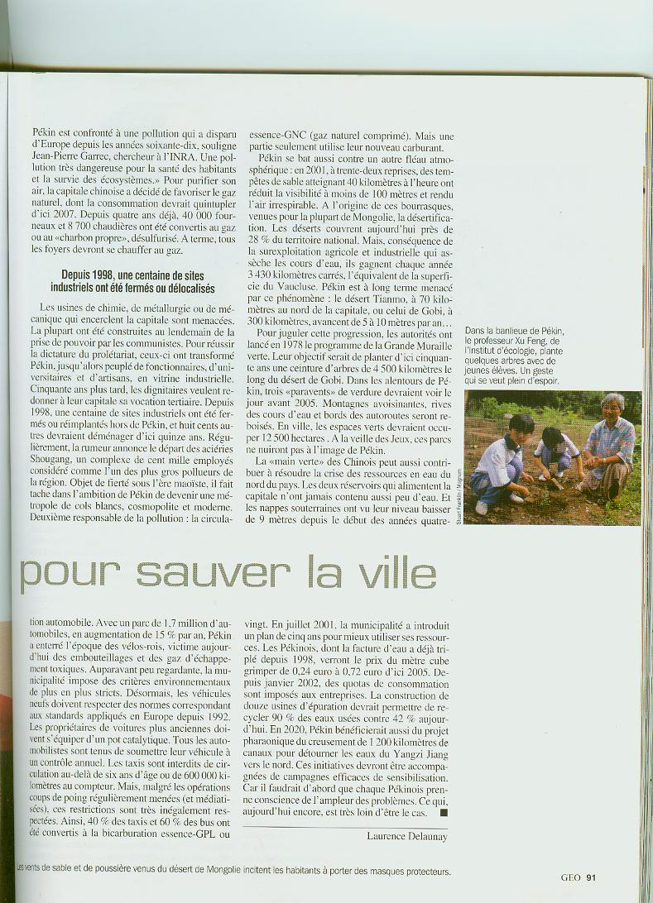

I ECOUTE ET COMPREHENSION.

  - du canard laqué
  - des nouilles
  - des haricots verts

  - les usines
  - les braseros des restaurants
  - les gens qui fument

  - d’écologie
  - des transports
  - des animaux

  - premier
  - troisième
  - cinquième

  - huit milliards de dollars
  - dix milliards de dollars
  - douze milliards de dollars

6.
a) la pollution
b) la chaleur
c) le froid

II IDEES PRINCIPALES

Devant votre audience, vous leur donnez les 3 idées principales du texte en français en vos propres mots.

III C’est l’heure des questions de votre audience. Répondez aux questions en français en vos propres mots.

Quels sont les trois fléaux de la pollution à Pékin?

- Comment Pékin a-t’elle été transformé afin de réussir la dictature du prolétariat?

- Combien de sites industriels devraient quitter Pékin dans les 15 prochaines années?

- Pourquoi la circulation automobile est-elle un grand problème?

- Qu’est-ce qui a été lancé en 1978? Quel est son objectif?

- Quelle est la raison pour tant de changements si soudain?

- Est-ce que Pékin a beaucoup de ressources en eau? Expliquez.

- Les normes de quel pays Pékin doit-il respecter en ce qui concerne les critères de l’environnement?

- Quel est le problème avec les tempêtes de sable? Expliquez.

- Qu’est-ce qui va permettre d’épurer 90% des eaux usées?

- Quel est l’âge maximum qu’un taxi peut avoir pour circuler librement?

- Pourquoi les Pékinois doivent-ils certains jours porter des masques?

- Quand les principales usines ont-elles été ouvertes à Pékin?

- Qu’est ce qui dit aux Pékinois de protéger l’environnement?

- Combien y-a-t’il d’organisations non-gouvernementales pour l’écologie à Pékin?

- Quel est le handicap de la candidature de Pékin pour la sélection d’organisateur des Jeux Olympiques de 2008?

17) Quel est le combustible le plus utilisé par les Pékinois? Pourquoi?

IV Trois personnes sont vraiment très impressionnées devant le discours que vous avez pronouncé et vous demandent des explications très précises. Répondez en donnant une définition complète des mots qu’elles ne comprennent pas.

- prolétariat

- être tabou

- un réservoir

IV Pensez vous que les différences culturelles entre tous les pays qui participent aux Jeux Olympiques et les nécessités de tant de changements pour être organisateur peuvent aider la Chine à évoluer économiquement?

Répondez à cette question en 4 phrases.

Pre-Advanced Interpretive Rubric
La croisade verte pour sauver la vil

 | EXCEEDS EXPECTATIONS | MEETS EXPECTATIONS | DOES NOT MEET EXPECTATIONS
Literal Comprehension | Identifies the main idea of the text and supporting details. | Identifies the main idea of the text and some supporting details. | Identifies the main idea of the text and a few supporting details.
Interpretive Comprehension | Infers meaning of unfamiliar words in new contexts.  Interprets the author’s intent, perspective and expresses his/her own perspective. | Infers meaning of some unfamiliar words in new contexts.  Interprets some of author’s intent, perspective and expresses some of his/her own perspectives. | Infers meaning of cognates and word families and a few unfamiliar words in new contexts.  Does not interpret author’s intent, perspective or express his/her own perspective.
Cultural Awareness | Is able to infer cultural perspectives. | Is able to infer some cultural perspectives. | Is able to infer few or no cultural perspectives.

TOA Title: La croisade verte pour sauver la vil

Task Title: Story: Une croisade verte pour sauver la ville.

Theme: Environment

Level: Pre-Advanced Focus Age Group: 15 – 18 years

National Standards Goals: Communication Cultures Connections Comparisons Communities

Communicative Mode: Interpersonal

Time Frame: Depending upon class size, about 10 minutes for each pair of students.

Description of Task:
The students will pick the card with the text. By pairs, they will have to discuss in front of the teacher the subject stated on the card. They will not have the time to talk with each other before discussing in front of the teacher.

Peking is a big town. You know that since you spent your summer break there. Your friend went to spend his/her vacation in another major town (of his/her choice). You will discuss the pollution problems, possible solutions to the problems, prevention, actions already taken, problems solved… Do you think the problems depend on the weather, economics? What great improvement do you think is the most important?
Discuss with your partner.

Materials Needed: Recorded text, the text, paper and pencil.

Teacher Notes: Students have knowledge about the problems of pollutions in the world, know about recycling, and actions taken to prevent the pollution. The teacher will have to be alone with the students during the presentations in order for the remaining students not to get ideas from students who are presenting.

Pre-Advanced Interpersonal Rubric
La croisade verte pour sauver la vil

 | EXCEEDS EXPECTATIONS | MEETS EXPECTATIONS | DOES NOT MEET EXPECTATIONS
Language Function | Describes in past, present and future with detail most of the time.  Is very accurate in present, past, and future. | Narrates and describes some of the time in past, present, and future.  Is most accurate in present tense and is less accurate when speaking in past and future. | Is most accurate in the present tense. Accuracy decreases significantly when speaking in past and future.
Communication Strategies | Starts, continues, and/or redirects conversation and is able to clarify in many different ways.  Is able to circumlocute. | Starts and maintains conversation and sometimes is able to clarify.  Is able to circumlocute at times. | Can keep the conversation going and can ask and answer questions.  Is not able to circumlocute successfully.
Comprehensibility | Is easily understood by native speakers, even those unaccustomed to interacting with language learners. | There may be some confusion about the message but generally understood by those unaccustomed to working with language learners. | Generally understood by those used to interacting with language learners.
Text Type | Speaks in paragraphs and connected sentences. | Speaks in paragraphs sometimes, but mostly connected sentences. | Speaks in strings of sentences, some complex sentences.
Vocabulary | Consistently uses an extensive vocabulary to complete the task. | Uses an adequate vocabulary to complete the task. | Uses vocabulary insufficient to complete the task.
Comprehension | Responses demonstrate understanding. | Responses demonstrate understanding most of the time. | Responses demonstrate occasional understanding.
Cultural Awareness | Consistently provides evidence of culturally appropriate language and gestures.  Demonstrates an understanding of culture through comments and questions. | Provides some evidence of culturally appropriate language and gestures.  Demonstrates some understanding of culture through comments and questions. | Provides little evidence of culturally appropriate language and gestures.  Demonstrates little understanding of culture.

TOA Title: La croisade verte pour sauver la vil

Task Title: Une croisade verte pour sauver la ville.

Theme: Environment

Level: Pre-Advanced Focus Age Group: 15 – 18 years

National Standards Goals: Communication Cultures Connections Comparisons Communities

Communicative Mode: Presentational

Time Frame: One 45 minute class period

Description of Task:
You have just returned from China, and you have to create a report for the Olympic Committee to help them choose the city that will host the Olympic Games. The report should address why the Committee should choose the city of your choice, what the city must do to be ready for the 2012 games.

Write a structured composition in 30 sentences or more. Your composition needs to include an introduction, a development, and a conclusion.

 | EXCEEDS EXPECTATIONS | MEETS EXPECTATIONS | DOES NOT MEET EXPECTATIONS
Language Function | Describes in past, present and future with detail most of the time.  Is very accurate in present, past and future. | Narrates and describes some of the time in past, present and future.  Is most accurate in present tense and is less accurate when speaking in past and future. | Is most accurate in the present tense. Accuracy decreases significantly when speaking in past and future.
Communication Strategies | Organizes presentation in a logical manner with some cohesive devices. Speaks/writes with fluency. Includes anecdotes and detailed examples. | Organizes presentation in a logical manner with few cohesive devices. Pauses a few times, disrupting the flow. | Focuses mostly on task completion; paying little attention to organization and flow of presentation.
Comprehensibility | Is easily understood by native speakers, even those unaccustomed to interacting with language learners. | There may be some confusion about the message but generally understood by those unaccustomed to working with language learners. | Generally understood by those used to interacting with language learners.
Text Type | Speaks/Writes in paragraphs and connected sentences. | Speaks/Writes in paragraphs sometimes, but mostly connected sentences. | Speaks/Writes in strings of sentences, some complex sentences.
Vocabulary | Consistently uses an extensive vocabulary to complete the task. | Uses an adequate vocabulary to complete the task. | Uses vocabulary insufficient to complete the task.
Cultural Awareness | Consistently provides evidence of culturally appropriate language and gestures. | Provides some evidence of culturally appropriate language and gestures. | Provides little evidence of culturally appropriate language and gestures.

Pre-Advanced Presentational Rubric
La croisade verte pour sauver la vil

